Coating Specification Sheet

Anodizing (HC – GL Method)

Revision Revision Date Revision Name
A 08-10-01 0 Wimmer S.

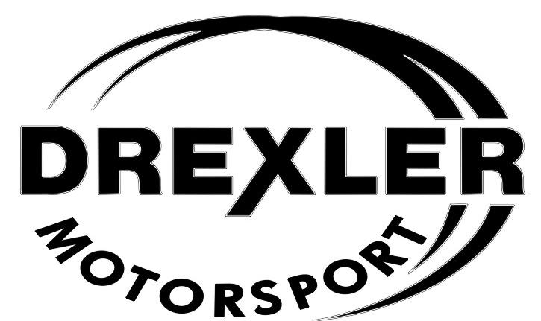

Drexler Motorsport GmbH
D - 94121 Salzweg
Postgasse 12c
Tel: +49 / 851 / 851 63 63 0
Fax: +49 / 851 / 851 63 63 63

Coating Specification Sheet

Anodizing (HC – GL Method)

Table of contents

1. Need of the Coating ………………………………….. 3
2. Application ………………………………………………….. 4
3. Coating Description …………………………………. 4
3.1. Coating Method …………………………………. 4
3.2. Coating Matrix .………………………………………………….... 4
3.3. Coating hickness …………………………………………… 4
3.4. Surface Standards ………………………... 5
3.5. Physical Property …………………………………. 5
3.6. Activation ……………………………………………………. 5
3.7. Coating ……………………………………………………. 5
4. Quality Control ………………………………………....... 6
4.1. Steps to be done by the Supplier ….…………... 6
4.1.1. Optical Control …………………………………………… 6
4.1.2. Quality Control …………………………………………… 6
4.2. Steps to be done at Drexler Motorsport GmbH … 6
4.2.1. Optical Control ………………………………………….. 6
4.2.2. Quality Control ………………………………………….. 6
5. Supplier …………………………………………………… 7

Coating Specification Sheet

Anodizing (HC – GL Method)

1. Need of the Coating:

HART-COAT® is a functional Aluminium-Refinement. The characteristics of the HART-COAT® coating are depending on the treated material and it’s necessary coating parameters which can be individual adjusted to the different needs.

- Wear resistance and hardness: The high wear resistance is due to the hardness and morphology of the aluminium oxide, which is depending on the coating. The reachable hardness of the HART-COAT® coating, depending on structure and consistency of the material, is between 400 and 500 HV 0,025.
- Heat conductance: Is ¹/₁₀ to ¹/₃₀ of the ground material heat conductance.
- Heat Resistance: HART-COAT® coatings can resist peaks of 2.200 K.
- Specific electrical resistance: At 20°C 4×10¹⁵ Ω cm, at 100°C 0,8×10¹⁵ Ω cm and at 200°C 0,11×10¹⁵ Ω cm.
- Dielectric strength: Is depending on the coating and rises the higher the coating becomes but not proportional. An arithmetic mean out of 10 measurements according ISO 2376 is at 30 µm HC on AlMgSi1: 914 V and at 50 µm HC on AlMgSi1: 1213 V.
- Colour: The colour possibilities from HART-COAT® are grey to black, at HC-CU green grey to dark blue and at a HC-GL coating gold to grey yellow.
All mentioned technical figures are valid under the test condition at the supplier. We clearly advise, that just a coating test at the operator or user of the coating can tell the real performance of the coating and its system!

Coating Specification Sheet

Anodizing (HC – GL Method)

2. Application:

- Differential Housing Formula Student 2008 – 2009
- Differential Cover Formula Student 2008 – 2009
- Chain wheel flange Formula Student 2008 – 2009

3. Coating Description:

- Hard Coat® Method (anodizing)

- HART-COAT® is a special developed coating for functional refinement of Aluminium materials.
The coating process happens in a cooled Acid. The component is the anode and oxidises during the treatment. Due to the oxidation the surface of the treated material transforms into a ceramic layer! These Aluminiumoxid layer consists mainly from amorphous y-Aluminiumoxid, which builds up regular cells, vertical to the component surface. It covers the component and secures it against wear and corrosion.

3.1. Coating Method:

- Hard Coat® Method (anodizing)

3.2. Coating Matrix:

- Amorph y-Aluminiumoxid

3.3. Coating thickness:

- 30µm (½ goes inside the component and ½ is added to the surface of the component)

Coating Specification Sheet

Anodizing (HC – GL Method)

3.4. Surface Standards:

- Non

3.5. Physical Property:

- Higher wear resistance
- Higher corrosion resistance
- Improved slighting behaviour
- Surface hardness: 450 – 480 HV0,025
- No material distortion (max. process temperature 100°C)
- Linear thermal coefficient of expansion: ~ 1/5 of the ground material
- Temperature capacity: peaks of 2200K
- Look and colour: gold yellow to grey yellow

3.6. Activation:

- Happens through the sour acid

3.7. Coating:
- The HC – GL coating is formed by anodizing in a sour and cold acid with a special consistency.
When electricity is applied a covering and securing Aluminiumoxid coating is created! This coating can, depending of the material, reach a thickness up to 200µm
- Surface Condensation (after coating process is finish):
Done in 90°C to 100°C hot water without any additives to close the porosity
With this process the wear resistance of the component increases!

Coating Specification Sheet

Anodizing (HC – GL Method)

4. Quality Control:

4.1. Steps to be done at the supplier:

4.1.1. Optical Control:

- A 100% optical control of the components is necessary and obligatory.

4.1.2. Quality Control:

- Has to be documented in the job card
- On customer request a certificate has to be handed out

4.2. Steps to be done at Drexler Motorsport GmbH:

4.2.1. Optical control:

- To avoid any of the following errors!
- Errors are: Split offs, porosity, scratches, coating shadows and foreign particle
- Random Test of the fit diameter (dimension and roundness)

4.2.2. Quality Control:

- The completeness of the control on the quality document has to be checked and compared with it’s own control!

Coating Specification Sheet

Anodizing (HC – GL Method)

5. Supplier:

AHC – Oberflächentechnik GmbH

Werk 3
Klausner Ring 28
D – Kirchheim-Heimstetten
Deutschland
Tel: 0049(89)990241-0
Fax: 990241-10
e-Mail: info.muenchen@ahc-surface.com
info.berlin@aimt-group.com
http://www.aimt-group.com
http://www.aimt-group.com/340-0-verfahrensstandorte.php

